Naïve Based

Tweeter- tweets- Positive and Negative

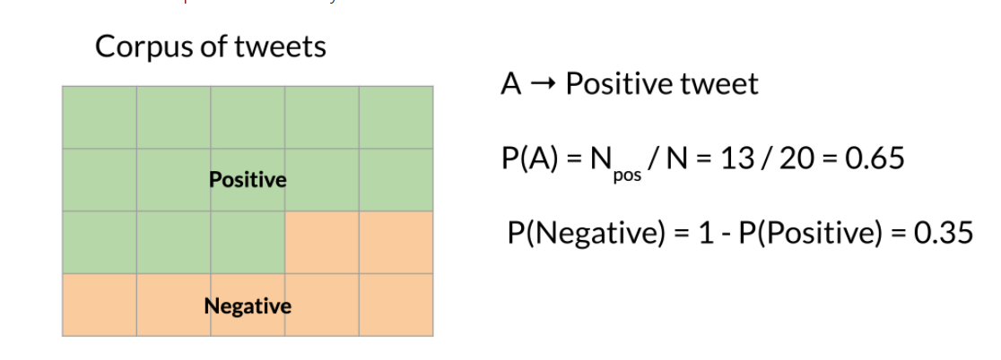

Conditional Probability – Probabilty of a event B given that A has already happened

Probabilty of a tweet being Possitve given that it has the word Happy

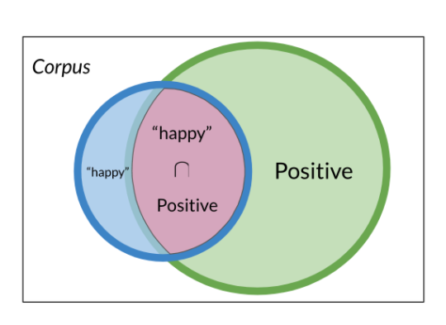

P(Positive| Happy) = P( Happy|Positive) \* P(Positive)/P(Happy)

Bayes' rule states that the probability of X

given Y is equal to the probability of Y given X times the ratio of

the probability of X over the probability of Y and that's it

Naïve Based

Naïve because it assumes that the features are all independent of each other

Naive Bayes classifier assumes that the effect of a particular feature in a class is independent of other features. For example, a loan applicant is desirable or not depending on his/her income, previous loan and transaction history, age, and location. Even if these features are interdependent, these features are still considered independently. This assumption simplifies computation, and that's why it is considered as naive. This assumption is called class conditional independence

Calculate the Freq(W | Class)



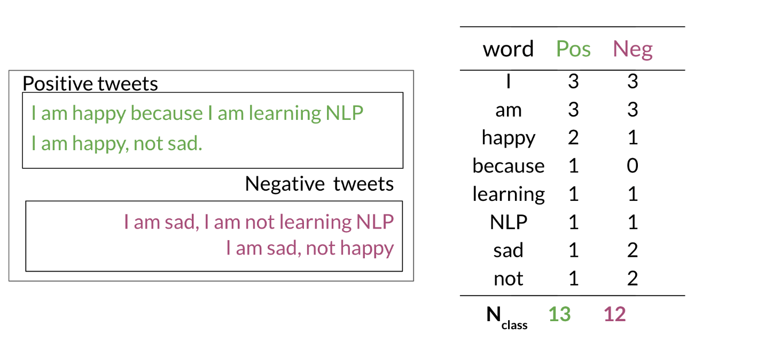



P(I | Pos)= 3/13= 0.24

P(I | Neg) = 3/12= 0.25

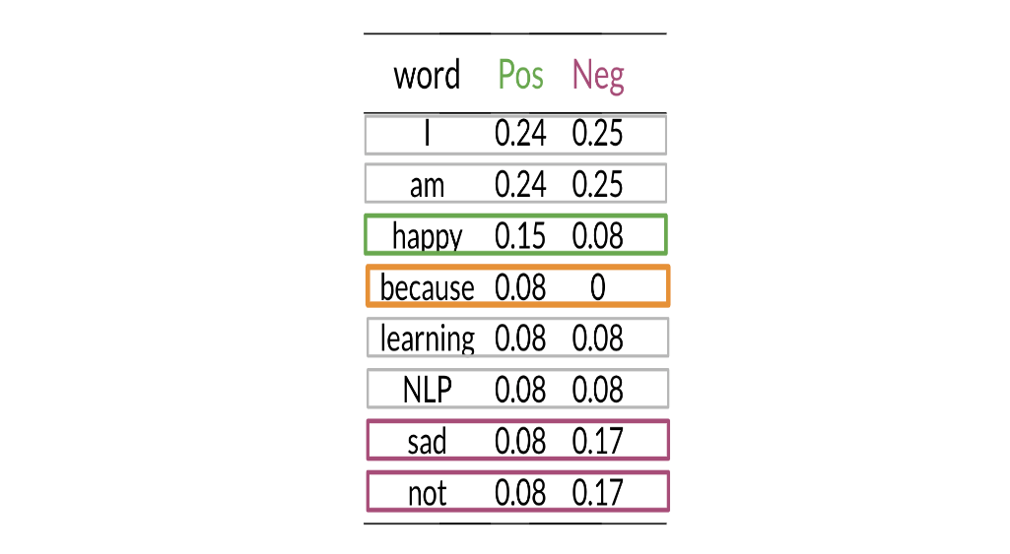

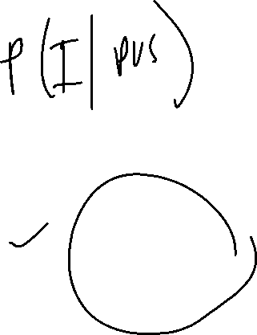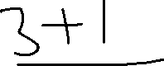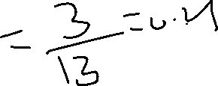

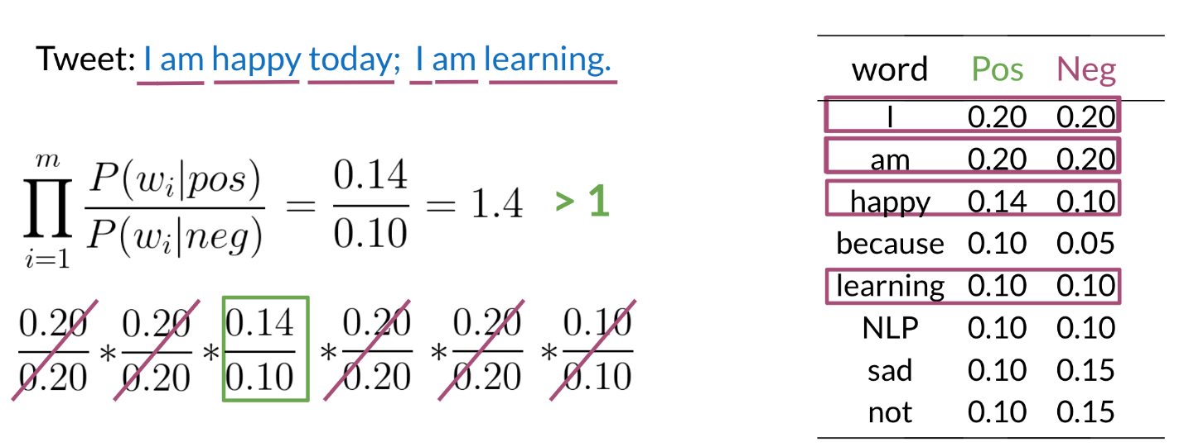

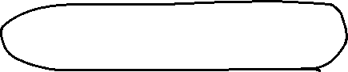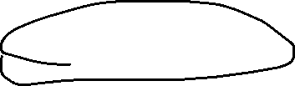

Product of Ratio value greater than 1- refers to positive sentiment



